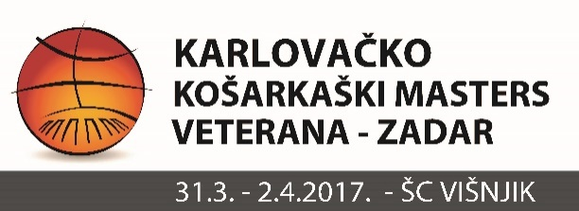

M 35+
PET BUNARA (ZADAR)
ADRIATIC (SPLIT)
ENIKON (ZAGREB)
DUBRAVA (ZAGREB)
VKK BIGRAF MLADOST (ZAGREB)

1.KOLO
PET BUNARA – ADRIATIC 63:50
DUBRAVA – VKK BIGRAF MLADOST 44:43
ENIKON – PET BUNARA 48:70
2.KOLO
DUBRAVA – ADRIATIC 67:72
ENIKON – VKK BIGRAF MLADOST 52:46
ADRIATIC – ENIKON 47:59
PET BUNARA – DUBRAVA 61:51
3.KOLO
VKK BIGRAF MLADOST – ADRIATIC 73:47
ENIKON – DUBRAVA 57-52
PET BUNARA – VKK BIGRAF MLADOST 43:56

POREDAK
RANK | TEAM | W | L | PTS+ | PTS- | +/-
1 | PET BUNARA | 3 | 1 | 194 | 146 | 48
2 | ENIKON | 3 | 1 | 159 | 163 | -4
3 | BIGRAF MLADOST | 1 | 2 | 162 | 142 | 20
4 | DUBRAVA | 1 | 3 | 162 | 176 | -14
5 | ADRIATIC | 1 | 3 | 216 | 262 | -46
NAJBOLJI STRIJELAC TURNIRA : SLAVEN RIMAC ( ENIKON ) - 78 KOŠEVA

MVP TURNIRA : IVAN ZRILIĆ ( PET BUNARA )

